PERSONAL PORTFOLIO WEBSITE
Project Documentation
Project Title:
Personal Portfolio Website
Submitted By:
Adlin A
Intern ID:
CITS3666
Organization:
Codtech IT Solutions Pvt. Ltd.
Domain:
Frontend Web Development
Duration:
4 Weeks

Submitted as part of the
Frontend Web Development Internship
at
Codtech IT Solutions Pvt. Ltd.

Project Overview
The Personal Portfolio Website is a responsive web application developed using HTML and CSS. The project showcases educational background, technical skills, projects, career goals, and contact information in a professional and visually appealing format.

Objectives
- Create a professional online portfolio
- Showcase skills and projects
- Develop a responsive website
- Improve frontend development skills

Technologies Used
- HTML5
- CSS3
- Responsive Web Design

Features
- Hero Section
- About Me Section
- Skills Section
- Projects Showcase
- Contact Section
- Mobile Responsive Design
- Smooth Navigation

Project Scope
The project serves as a digital portfolio for academic, internship, and professional opportunities. It provides a centralized platform to present technical skills, projects, and personal achievements.

Screenshots

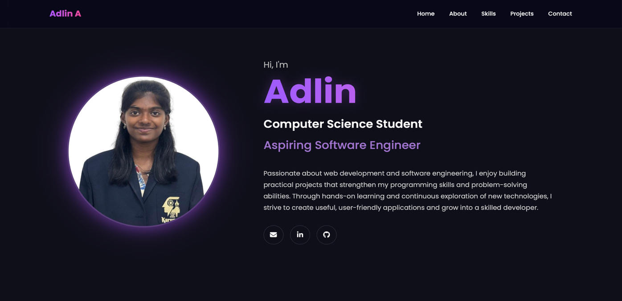

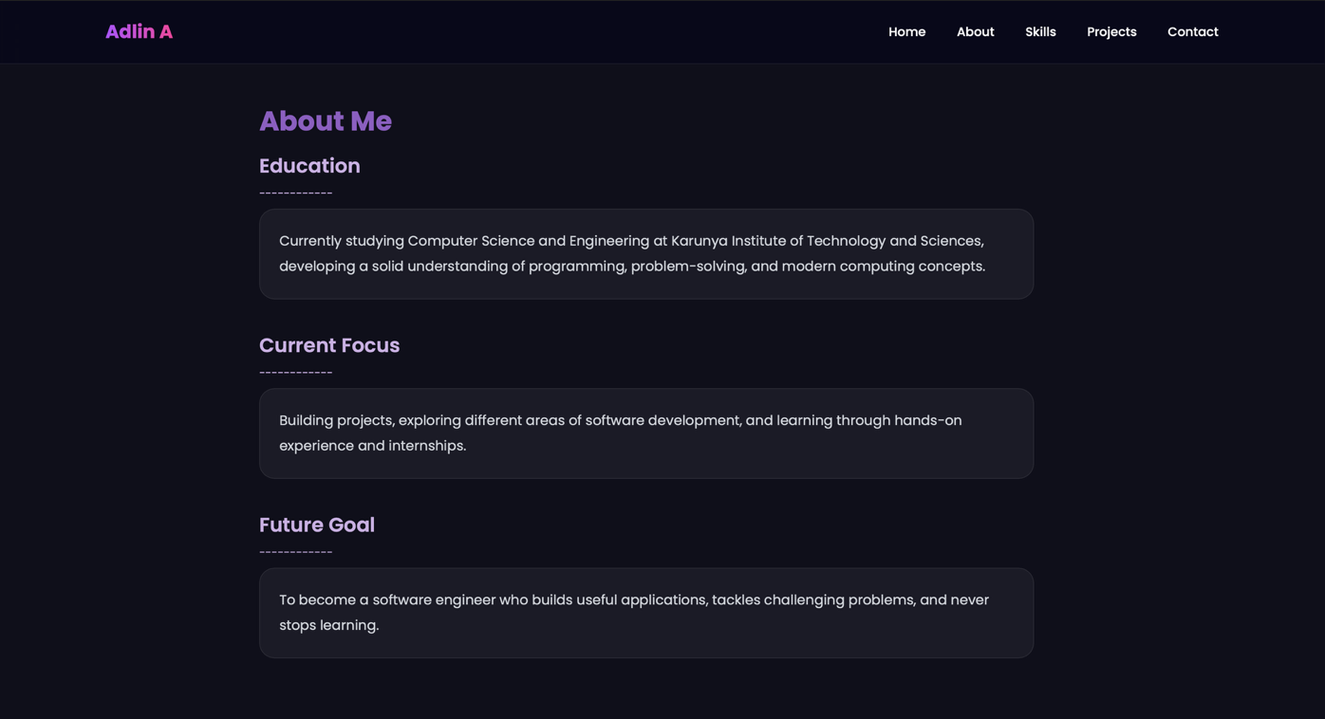

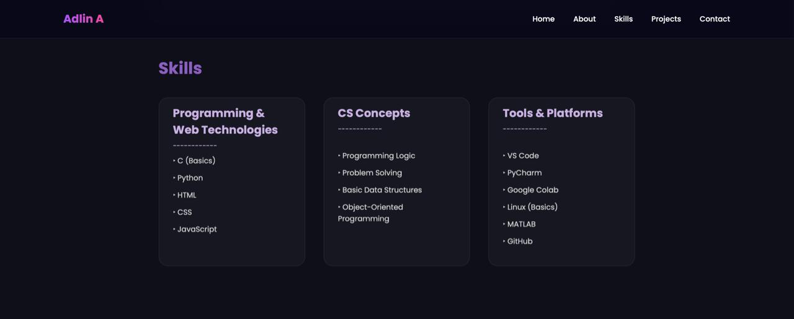

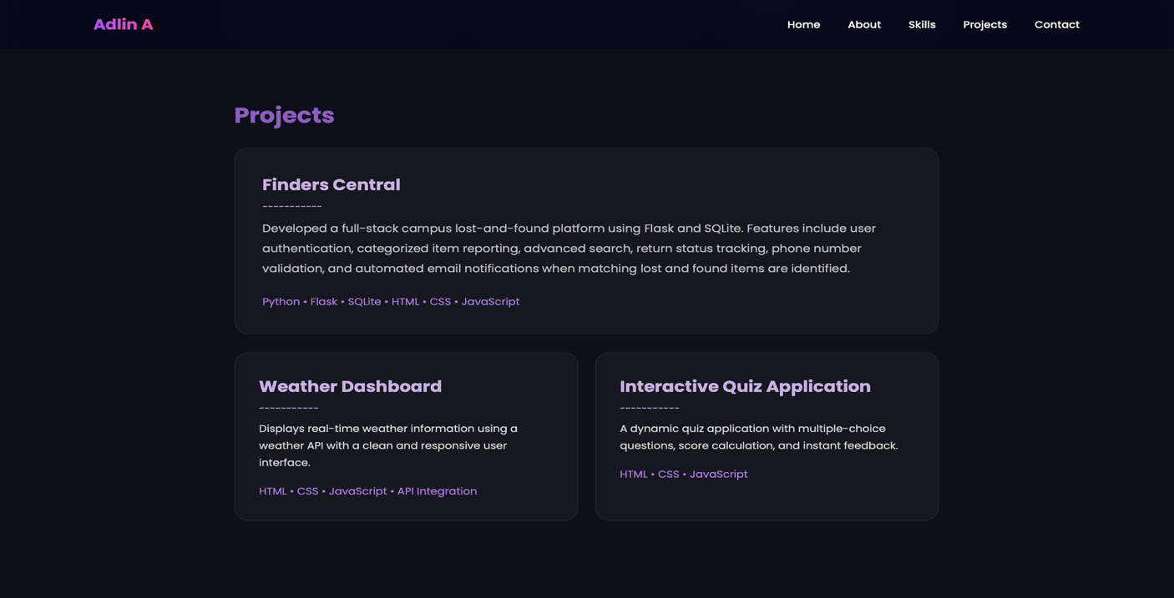

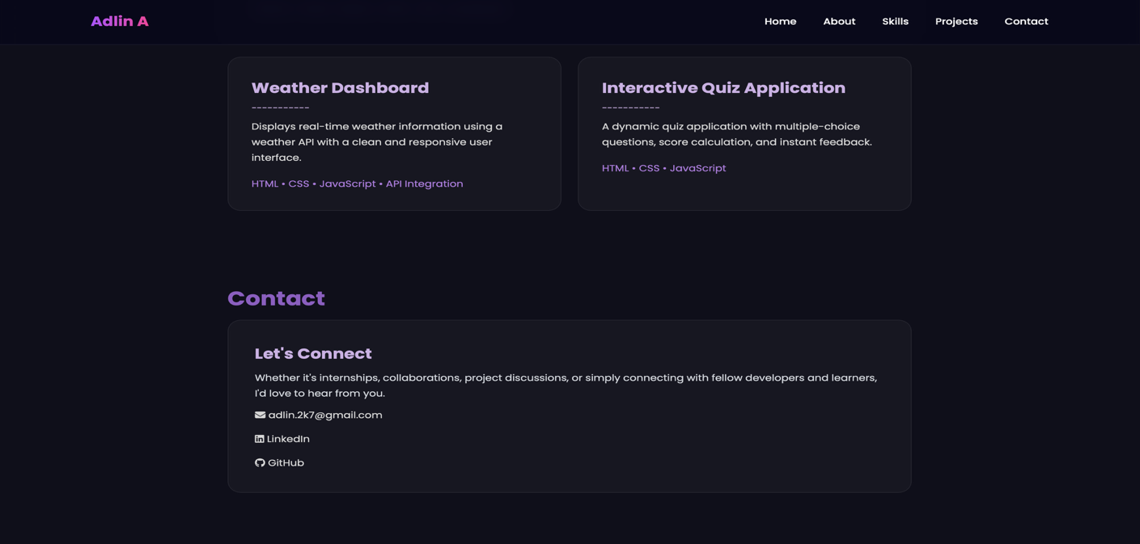

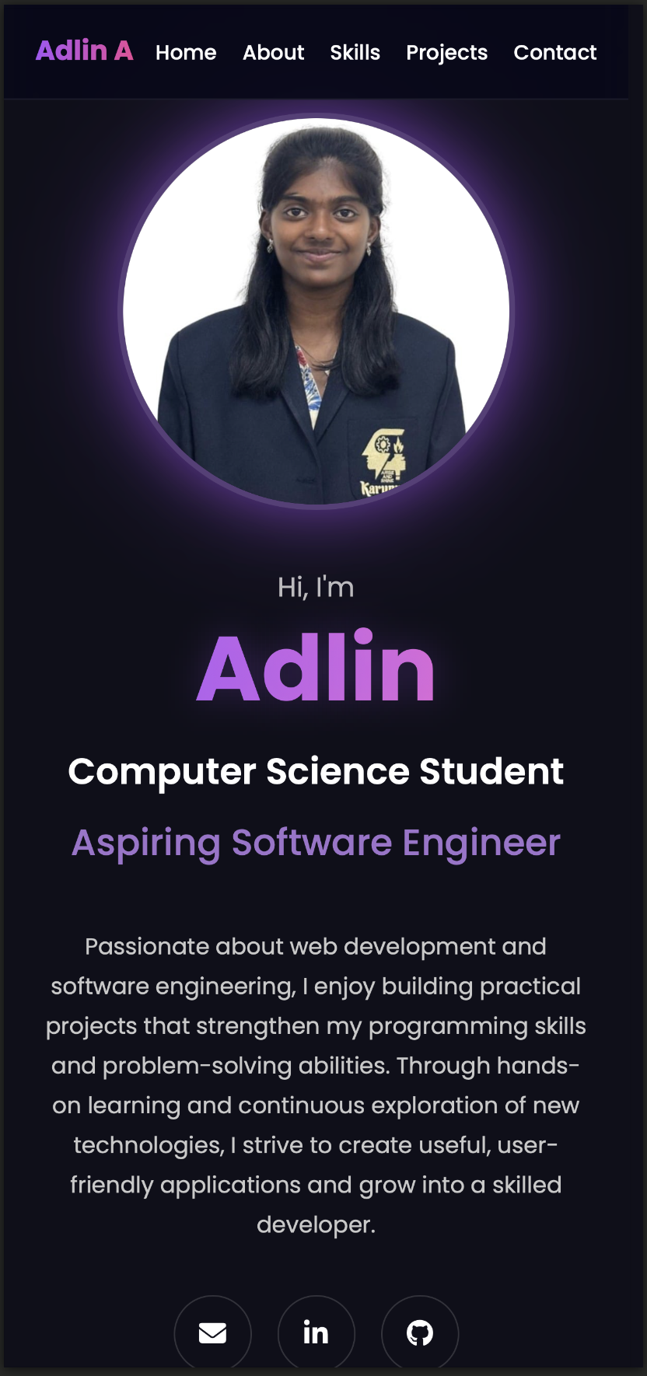

Future Enhancements
- Add JavaScript animations
- Add downloadable resume
- Add live project links
- Add additional projects

Conclusion
The Personal Portfolio Website successfully provides a professional platform to showcase personal information, technical skills, projects, and career goals. Through this project, I strengthened my understanding of HTML, CSS, responsive design, and frontend development principles. The website maintains a clean user interface and delivers a consistent experience across desktop and mobile devices.

